Analysis, Design, Test Document

Table of Contents

- A brief description of the approach taken: technical (choice of language, tools, type of diagram) and modelling (how you chose the abstractions, design patterns
- etc.) - max 2 sides A4

The language chosen by our group for implementing program and performing the tasks is Java. Java is the main language we have been taught and it is well known to ever member of our group. We are comfortable with popular Java IDEs like Eclipse and NetBeans and therefore by using them coding seemed more easy.
Various other tools were used, such as Microsoft Project for creating the Gantt Charts presenting an initial work breakdown and time allocation. Visual Paradigm was used to produce the UML diagrams : Sequence diagram, class diagram, use case diagram. As far as file sharing between the group members is concerned, Dropbox was used as a first instance, but a project was set up in ECS Forge and commitments and updates were achieved via it. By using SVN everyone was able to commit changes and download the latest versions of the project files and documents. Moreover, by using SVN Forge, simultaneous altering on files from different people was feasible without any loss or false change of data. The diagrams produced, as mentioned above were aiming to demonstrate fully the project abstraction.
The MVC or “Model-View-Controller” pattern was agreed to be followed as it was considered more suitable for our project. The reason for our choice is that MVC distinguishes between the Model and the Controller. Therefore the design and implementation of the system can be easily shared and implemented among the group members. The GUI that is demonstrated in the View, the Controller and the Model were assigned to the group members.

First of all the group met and produced the Sequence diagram and the following class diagrams : the Sequence diagram, the use case diagram and the class diagrams. Three class diagrams have been produced demonstrating the Model, the View and the Controller respectively.

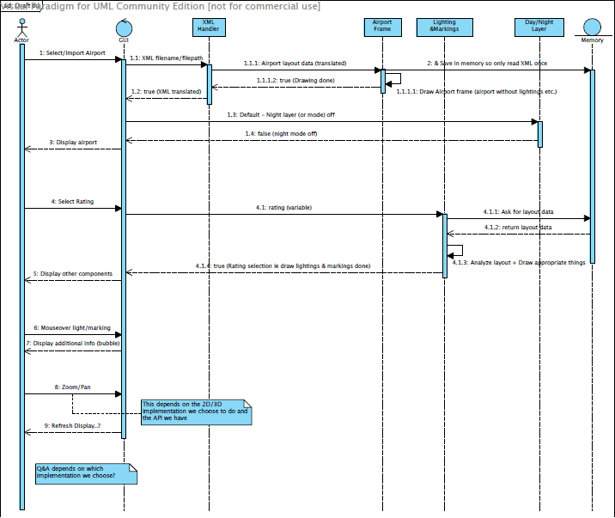

Figure 1: Sequence diagram

Figure 1 demonstrates the Sequence diagram produced. The user accesses the program and views the main page of the program, which is referred to as the GUI. The user selects to import an airport and then the airport loads on the canvas panel. The whole job is done by the XML handler that reads the airport frame in an XML file and loads the airport. Then, the user can select amongst many options regarding the display of the airport, such as to switch between day and night view or to rate the airport according to a category, in order to get the necessary markings and lights.
The Model is responsible for the background job to be done, whilst the user does the foreground work by viewing the View and by handling the airport display.

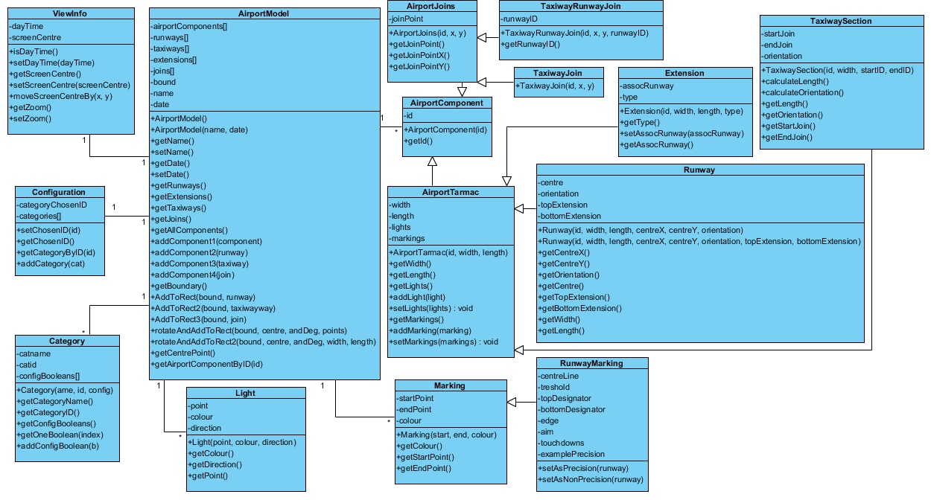

Figure 2: Class diagram - Model

The View is what the user sees and the includes the whole GUI. For instance, the user sees a start-up window and a main window when accessing the system. Moreover, there is a Toolbox where all the options concerning the airports are placed. There is also a navigation bar at the top displaying important features such as the switching between a Plan (2D view) and a 3D view, as well as the Glossary window where the user can add or view terms concerning the airfield. The view is demonstrated in Figure 3.
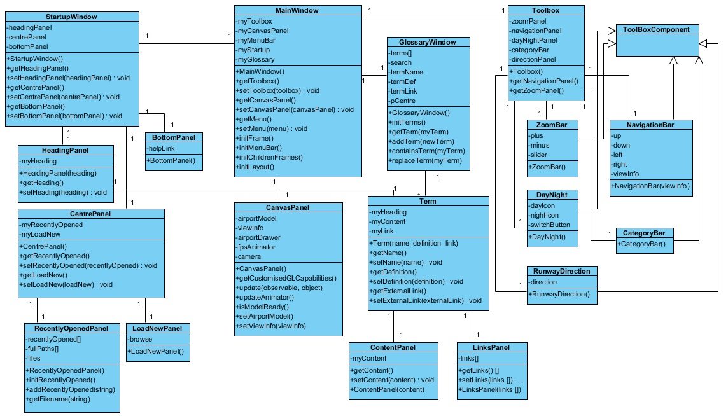
Figure 3: Class diagram - View

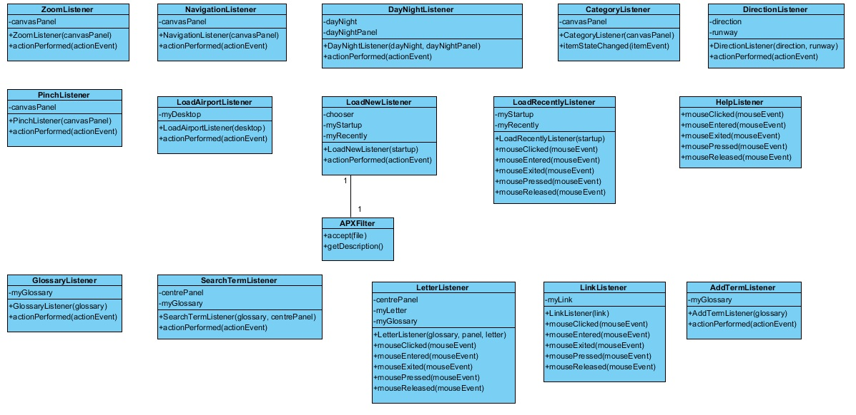
Figure 4 : Class diagram - Controller
Figure 4 presents the Controller that includes classes to handle the various listeners that can be found on buttons or on the toolbar.
Moreover, a class diagram was created, demonstrating the XML parser or handler. In the diagram five classes are shown. Two of them are the AirportXmlParser and ConfigXmlParser, which both extend a GeneralXMLParser class. Classes InvalidAirportXMLException and invalidConfigXMLException handle exceptions that may be caused whilst trying to run the AirportXmlParser and the ConfigXmlParser.

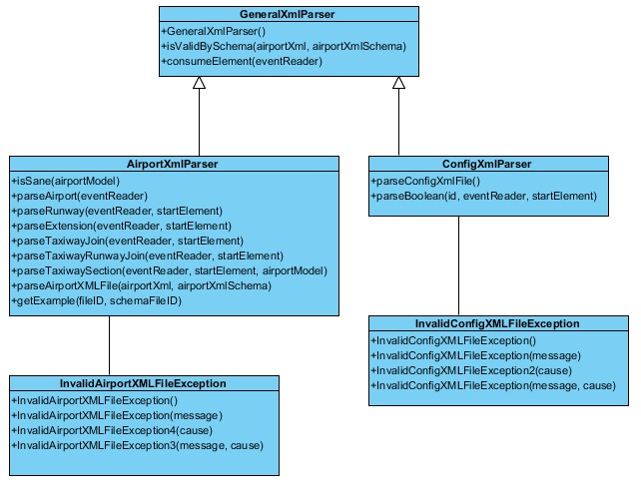

Figure 5 : Class diagram – XML parser

Every time anyone of the members finished a part of the system, testing was performed, not only by that person himself, but also by at least one more person. Below there is a table showing all the testing that took place.
system testing:
successfully login existing users
successfully register new users
do not allow users to continue if no username is submitted
do not allow users to continue if no initial keywords are submitted
successfully submit keywords of new users
successfully update keywords list if users add keywords
successfully
successfully retrieve resources from XML document
successfully calculate the cosine similarity between user and resource keywords
successfully calculating the idf of each keyword
successfully normalise idf according to document length

UI testing:
username to be shown on upper left corner of main screen
user keywords to be shown on left side of main screen
recommendations to be shown on right bottom of main screen in descending order
"add keywords" button to be shown on bottom left corner

Test number | Test script | Expected results
1 | System must authenticate the user | It should load a new window and give the user the option to browse through his files and load an airport
2 | New users shall be given command to submit keywords | Should load the Help file
3 | User keywords to be shown on main screen | It should zoom in the display
4 | Recommendations to be shown on main screen | It should zoom out the display
5 | Scrollbar on toolbox | It should show the accurate percentage of zooming as far as the display of the airport is concerned
6 | “Up” arrow on toolbox instant click | It should move up the display
7 | “Down” arrow on toolbox instant click | It should move the display downwards
8 | “Right” arrow on toolbox instant click | It should move the display rightwards
9 | “Left” arrow on toolbox instant click | It should move the display leftwards
10 | “Up” arrow on toolbox continuous click | It should keep moving the display upwards until the button is unselected
11 | “Down” arrow on toolbox continuous click | It should keep moving the display downwards until the button is unselected
12 | “Right” arrow on toolbox continuous click | It should keep moving the display rightwards until the button is unselected
13 | “Left” arrow on toolbox continuous click | It should keep moving the display leftwards until the button is unselected
14 | “Night/Day” view icon on toolbox | It should effectively switch the display between a day and night view. If day view, it will be changed to night view.
15 | “Night/Day” view icon on toolbox | It should effectively switch the display between a day and night view. If night view, it should be changed to day view.
16 | Select "Blank" on “Select category” drop-down list on toolbox | No markings and lights should be displayed.
17 | Select "Visual required" on “Select category” drop-down list on toolbox | The corresponding lights and markings should be displayed when selecting this category
18 | Select "Visual operationally desirable" on “Select category” drop-down list on toolbox | The corresponding lights and markings should be displayed when selecting this category
19 | Select " Non-Precision Required " on “Select category” drop-down list on toolbox | The corresponding lights and markings should be displayed when selecting this category
20 | Select "CAT I Required" on “Select category” drop-down list on toolbox | The corresponding lights and markings should be displayed when selecting this category
21 | Select "CAT I Operationally Desirable" on “Select category” drop-down list on toolbox | The corresponding lights and markings should be displayed when selecting this category
22 | Select " CAT II Required " on “Select category” drop-down list on toolbox | The corresponding lights and markings should be displayed when selecting this category
23 | Select "CAT II Operationally Desirable" on “Select category” drop-down list on toolbox | The corresponding lights and markings should be displayed when selecting this category
24 | Select "CAT IIIA Required " on “Select category” drop-down list on toolbox | The corresponding lights and markings should be displayed when selecting this category
25 | Select "CAT IIIA Operationally Desirable" on “Select category” drop-down list on toolbox | The corresponding lights and markings should be displayed when selecting this category
26 | Select "CAT IIIB Required " on “Select category” drop-down list on toolbox | The corresponding lights and markings should be displayed when selecting this category
27 | Select "CAT IIIB Operationally Desirable" on “Select category” drop-down list on toolbox | The corresponding lights and markings should be displayed when selecting this category
28 | Select "CAT IIIC Required" on “Select category” drop-down list on toolbox | The corresponding lights and markings should be displayed when selecting this category
29 | Select "CAT IIIC Operationally Desirable" on “Select category” drop-down list on toolbox | The corresponding lights and markings should be displayed when selecting this category
30 | “Change direction” of the runway button on toolbox | Upon click, the runway direction should be changed to face the opposite direction.
31 | “Change direction” of the runway button on toolbox | Upon click, the runway direction should be changed to face the initial direction.
32 | “Load airport” button on “File” drop down button on menu bar | It should display the start-up window
33 | “Close airport” button on “File” drop down button on menu bar | It should close the start-up window
34 | “Exit” button on “File” drop down button on menu bar | It should exit the system
35 | “Zoom/Reset zoom” button on “Edit” drop down button on menu bar | It should reset the zooming on the display
36 | “Centre display” button on “Edit” drop down button on menu bar | It should centre the display of the runway
37 | “Enable/Disable lights” button on “Edit” drop down button on menu bar | It should enable and disable the lights when the user selects a category
38 | “Enable/Disable markings” button on “Edit” drop down button on menu bar | It should enable and disable the markings when the user selects a category
39 | “Plan view” button on “View” drop down button on menu bar | It should switch the display to a 2D view
40 | “3D view” button on “View” drop down button on menu bar | It should switch the display to a 3D view
41 | “Question/Answer pane” button on “View” drop down button on menu bar | It should load the window that displays the Question/answer feature
42 | “Glossary” button on “Help” drop down button on menu bar | It should load the glossary window, where the user can add and/or read existing airport terms already added.
43 | “Help file” button on “Help” drop down button on menu bar | It should load the help file.
44 | “About” button on “Help” drop down button on menu bar | It loads a window that contains general information concerning the system.
45 | Add a question and an answer to the “Question/Answer” pane | The user should successfully add a question and an answer to the pane.
46 | Take the test in the “Question/Answer” pane | The user should be able to take the test concerning questions of the airfield and be given a score in the end
47 | View terms in the “Glossary” | The user should be able to see the terms already inserted into an alphabetical order, by pressing the starting letter of the term.
48 | Search terms in the “Glossary” | The user should be a be able to search for a term and if the term is saved it should then be displayed.
49 | Add terms to the “Glossary” | The user should be able to add a term by adding its name, definition and link.
50 | Display terms on canvas mouse click | When the user clicks on a runway, then the term “Runway” should be displayed and if the user presses it, the term definition should be shown.
51 | Keyboard "Up arrow" | It should move the display upwards
52 | Keyboard "Down arrow" | It should move the display downwards
53 | Keyboard "Right arrow" | It should move the display rightwards
54 | Keyboard "Left arrow" | It should move the display leftwards
55 | Mouse scroll button | It should zoom in and out the display
56 | Keyboard rotate rightwards | When pressing a specific button on the keyboard ">" , it should rotate the display rightwards
57 | Keyboard rotate leftwards | When pressing a specific button on the keyboard "<" , it should rotate the display leftwards

Below there is a demonstration of some of the outcomes of the tests described above.
Test number | Test script | Actual outcome
1 | Browse button on start-up window | When the browse button on the start-up window was pressed, the user was given the option to search through his directories and upload an appropriate XML file.
3 | “Plus” button on toolbox | The zoom in button on the toolbox was working by enabling the user to zoom in the display
4 | “Minus” button on toolbox | The zoom out button on the toolbox was working by enabling the user to zoom out the display
6 | “Up” arrow on toolbox instant click | The up button on the toolbox was working and the display is now moving upwards while clicking on it
7 | “Down” arrow on toolbox instant click | The down button on the toolbox was working and the display is now moving upwards while clicking on it
8 | “Right” arrow on toolbox instant click | The right button on the toolbox was working and the display is now moving upwards while clicking on it
9 | “Left” arrow on toolbox instant click | The left button on the toolbox was working and the display is now moving upwards while clicking on it
14 | “Night/Day” view icon on toolbox | The day view was successfully switched to a night view
17 | Select "Visual required" on “Select category” drop-down list on toolbox | When the "Visual required" category was selected the appropriate lights and markings were displayed
30 | “Change direction” of the runway button on toolbox | When this button was clicked, the direction of the runway successfully changed
37 | “Enable/Disable lights” button on “Edit” drop down button on menu bar | A category was selected and then the "Enable/Disable lights" button was clicked. The lights were successfully disabled.
38 | “Enable/Disable markings” button on “Edit” drop down button on menu bar | A category was selected and then the "Enable/Disable markings" button was clicked. The markings were successfully disabled.
39 | “Plan view” button on “View” drop down button on menu bar | The display successfully turned to a 2D display
43 | “Help file” button on “Help” drop down button on menu bar | The Help pdf file was successfully loaded when the button Help was pressed
45 | Add a question and an answer to the “Question/Answer” pane | A question was added to the pane and then the user was able to view it as well.
49 | Add terms to the “Glossary” | The user searched for a term that was not included in the glossary and therefore he could add it. He added the term's name, definition and a link. The term was successfully added to the glossary
50 | Display terms on canvas mouse click | When the user clicked somewhere on the runway, the term runway appeared.
56 | Keyboard rotate rightwards | The airfield display was rotating rightwards whilst the allocated keyboard button was pressed
57 | Keyboard rotate leftwards | The airfield display was rotating leftwards whilst the allocated keyboard button was pressed

